MT3TA4 Lab 5 Report

**Angular Resolution of the Motor:**

$$Angular Resolution= \frac{360°}{\# steps}=\frac{360°}{48}=7.5°$$

**Test Revolution Time:** 48 seconds / revolution

**Time Period Calculations:**

1. ***Half-Stepping Sequence:***

$T\left[\frac{s}{step}\right]= \frac{\frac{Seconds}{rotation}\left[s\right]}{\frac{Steps}{rotation}\left[step\right]}=\frac{48}{48×2(*)}=0.5\left[\frac{s}{step}\right]$ 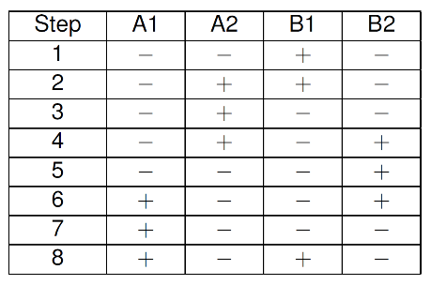

*Note: multiply the denominator by 2 since the half-stepping sequence takes twice as many steps to complete the same revolution as a full-stepping sequence in the same amount of time (48s)

1. 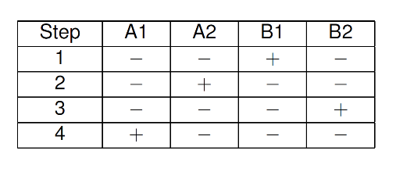***Full-Stepping Sequence:***

$$T\left[\frac{s}{step}\right]= \frac{\frac{Seconds}{rotation}\left[s\right]}{\frac{Steps}{rotation}\left[step\right]}=\frac{48}{48}=1\left[\frac{s}{step}\right]$$

**Prescalar and CCR Calculations**

In the lab you will use TIM3 of the STM32L476 to measure time periods. Assuming

the clock frequencies of both APB1 and APB2 domains of the STM32L476-Discovery board are configured as 4MHz, calculate the values for the prescaler and for the output compare register for TIM3 that will enable you to measure the time intervals calculated at steps 3a and 3b.

**C Code**